**🚀 Automatically Generate Architecture Diagrams using Amazon Q CLI and MCP Servers**

**Make sure your machine is updated and has Libfuse2 installed**

* sudo apt-get update
* sudo apt install libfuse2

**Install the deb file for Amazon Q**

* curl --proto '=https' --tlsv1.2 -sSf https://desktop-release.q.us-east-1.amazonaws.com/latest/amazon-q.deb -o amazon-q.deb

**Install Amazon Q debian file**

* sudo apt install -y ./amazon-q.deb

**Login into Amazon Q developer by creating a BuilderID**[**here**](https://community.aws/builderid?trk=529c4ce9-0395-4c42-915a-d70bf060ef3c&sc_channel=el)**followed by command**

* q login

**once you have logged in, just write simple command**

* q

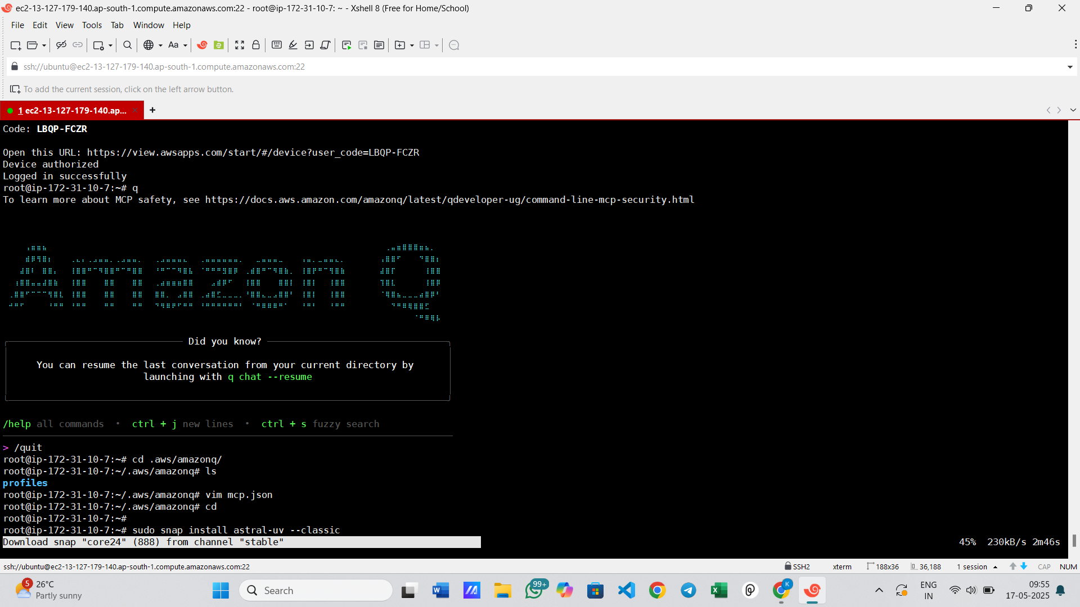

**MCP Support on Amazon Q CLI**

**Now let's power up your Amazon Q CLI with MCP Servers.**

**You need uv to install and Run MCP Servers**

* sudo snap install astral-uv --classic
* Now create a file called **mcp.json** in **~/.aws/amazon**

**and add this:**

**{**

**"mcpServers" : {**

**"awslabs.cdk-mcp-server": {**

**"command": "uvx",**

**"args": ["awslabs.cdk-mcp-server@latest"],**

**"env": {**

**"FASTMCP_LOG_LEVEL": "ERROR"**

**}**

**},**

**"awslabs.aws-diagram-mcp-server": {**

**"command": "uvx",**

**"args": ["awslabs.aws-diagram-mcp-server"],**

**"env": {**

**"FASTMCP_LOG_LEVEL": "ERROR"**

**},**

**"autoApprove": [],**

**"disabled": false**

**}**

**}**

**}**

**Now run q again:**

**You are all set now!**